          2.Spring-rest-handson

# Hello World RESTful Web Service

## Updated pom.xml:

```  
<project xmlns="http://maven.apache.org/POM/4.0.0"  
 xmlns:xsi="http://www.w3.org/2001/XMLSchema-instance"  
 xsi:schemaLocation="http://maven.apache.org/POM/4.0.0   
 http://maven.apache.org/xsd/maven-4.0.0.xsd">  
  
 <modelVersion>4.0.0</modelVersion>  
 <groupId>com.cognizant</groupId>  
 <artifactId>SpringLearn</artifactId>  
 <version>1.0-SNAPSHOT</version>  
  
 <dependencies>  
 <!-- Spring Boot Web -->  
 <dependency>  
 <groupId>org.springframework.boot</groupId>  
 <artifactId>spring-boot-starter-web</artifactId>  
 <version>2.7.18</version>  
 </dependency>  
  
 <!-- SLF4J Logging -->  
 <dependency>  
 <groupId>org.slf4j</groupId>  
 <artifactId>slf4j-api</artifactId>  
 <version>2.0.13</version>  
 </dependency>  
 <dependency>  
 <groupId>org.slf4j</groupId>  
 <artifactId>slf4j-simple</artifactId>  
 <version>2.0.13</version>  
 </dependency>  
 </dependencies>  
  
</project>  
```

## SpringLearnApplication.java:

```java  
package com.cognizant.springlearn;  
  
import org.springframework.boot.SpringApplication;  
import org.springframework.boot.autoconfigure.SpringBootApplication;  
  
@SpringBootApplication  
public class SpringLearnApplication {  
 public static void main(String[] args) {  
 SpringApplication.run(SpringLearnApplication.class, args);  
 }  
}  
```

## HelloController.java:

```java  
package com.cognizant.springlearn.controller;  
  
import org.slf4j.Logger;  
import org.slf4j.LoggerFactory;  
import org.springframework.web.bind.annotation.GetMapping;  
import org.springframework.web.bind.annotation.RestController;  
  
@RestController  
public class HelloController {  
  
 private static final Logger LOGGER = LoggerFactory.getLogger(HelloController.class);  
  
 @GetMapping("/hello")  
 public String sayHello() {  
 LOGGER.info("START: sayHello()");  
 String message = "Hello World!!";  
 LOGGER.info("END: sayHello()");  
 return message;  
 }  
}  
```

## application.properties:

```properties  
server.port=8083  
```

## OUTPUT:

In Browser:

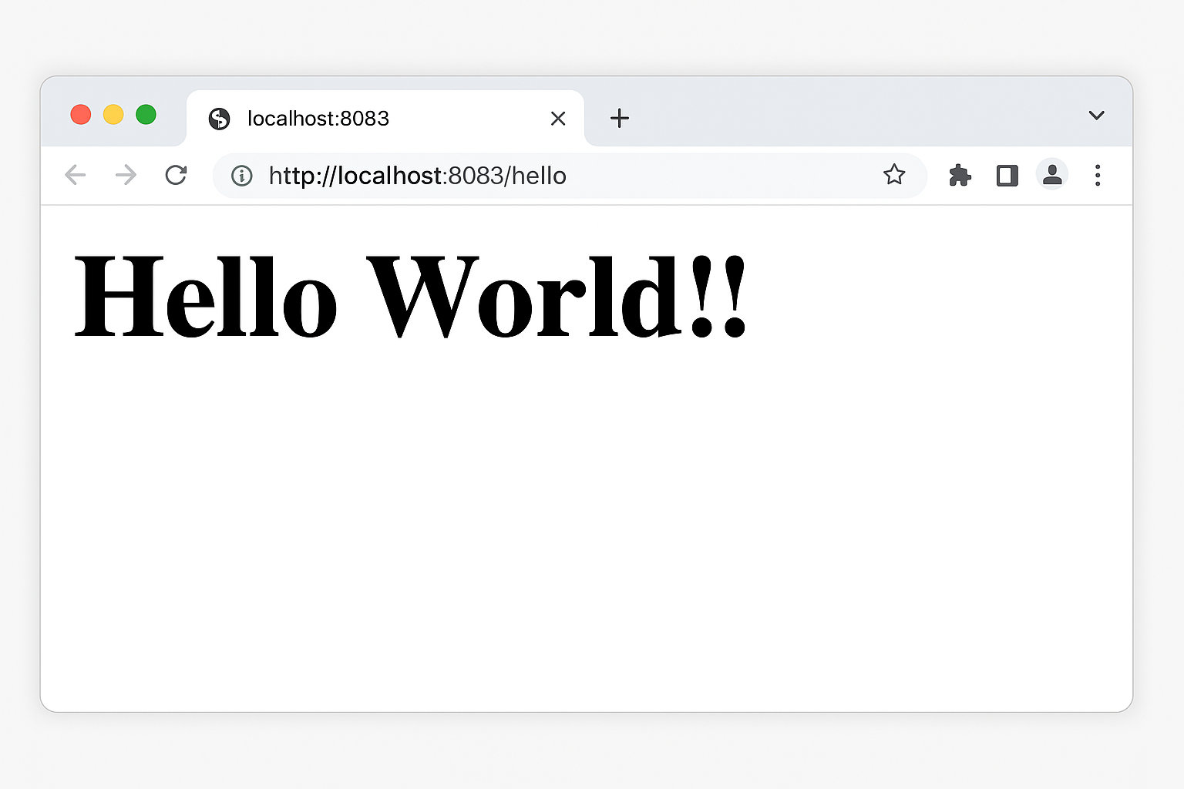

In Post man :

